[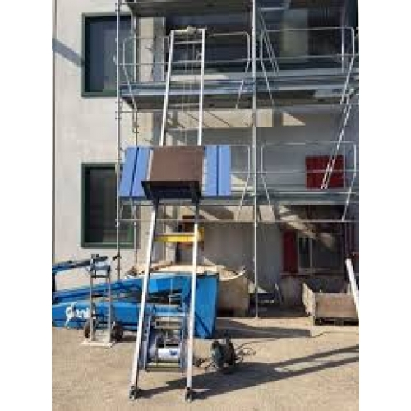](https://www.google.com/url?sa=i&rct=j&q=&esrc=s&source=images&cd=&cad=rja&uact=8&ved=2ahUKEwjC9rqVsezdAhXG66QKHXqzAGIQjRx6BAgBEAU&url=http%3A%2F%2Fsinc.lt%2Fkelimo-technika%2Fcerpiu-keltuvas-geda-lift-200&psig=AOvVaw1MyqQ7uN5tbywRRxAchgK7&ust=1538728590371301)